HANOI SPRING 1 DAY TOUR
https://jbatravelbox.com/tour/hanoi-city-tour-1-day/

DAY 1 | HANOI TOUR (LUNCH)
8:30 | Pick up from pick up points or your hotel in Hanoi Old Quarter.
Visit Tran Quoc Pagoda at West lake (One of the oldest pagodas in Vietnam).
Ba Dinh Square and visit the Ho Chi Minh Mausoleum to explore the architectural and historical aspects of Uncle Ho’s final resting-place.
Then visit Bat Trang pottery village (applied on Mon, Wed & Fri).
After lunch proceed to visit the Ethnology Museum (apply on Sun, Tue, Thu & Sat), the Literature Temple and Quoc Tu Giam, see Vietnam’s first university, constructed in 1070 - it’s gardens and well-preserved architecture will offer a relaxing glimpse into Vietnam’s past.
Take you past Hoan Kiem Lake to see the peaceful waters. and the beauty of Ngoc Son temple. In the end, journey through Hanoi’s Old Quarter, where you’ll then have a chance for some shopping and exploration.
Lunch at a local restaurant. Dinner will serve by yourself.
Tour ends around 15h30 - 16h00.

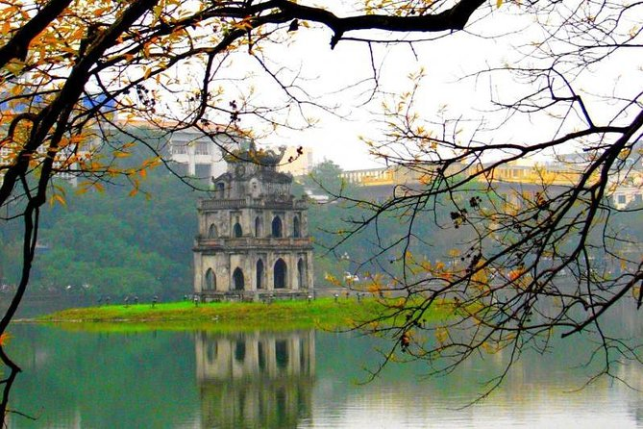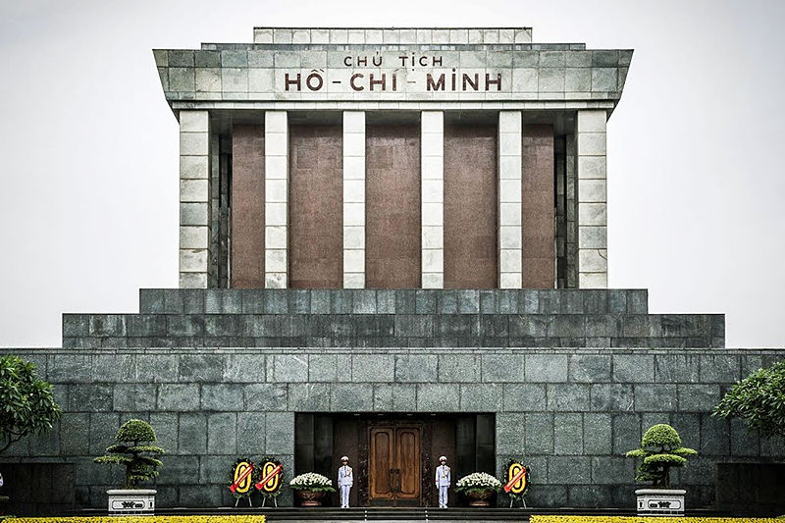

PRICE FOR CHILDREN:
- Free of charge for infant (below 5-year-old), other expense pay by parents
- 75% rate of adult for children from 5-8 year old
- 100% adult ticket for children over 8-year-old
- Two adults bring 2 children, The 2nd child will be charged 100% adult ticket
INCLUSIONS:
- Full transfers by A/C tourist car & 0.5l bottle water per person/day
- Free pick up and see off in Hanoi Old Quarter Area
- Entrance fee
- Set Menu Lunch
- English speaking guide
- Water Puppet Show or Cycling Tour (optional)
EXCLUSIONS:
- International airfares to VIETNAM & vice versa
- Tips for local tour guide and coach captain @ 3 USD/pax will be pre-collected.
- All kinds of personal and incidental bills
- Travel Insurance
- What not mentioned clearly
NOTE:Children under 3 years old are not allowed to get inside Ho Chi Minh Mausoleum
- Ho Chi Minh Mausoleum closed on Monday and Friday morning. And closes from 5th Sep to 31st October
- The itinerary can be changed due to weather...
- Special request (diet or vegetarian …) should be sent before your departure date.
- Water Puppet show for Deluxe option only.. Then the tour will finish around 17h00 - 17h30.
- Bat Trang pottery village can be visited on Mon, Wed & Fri (without Ethnology Museum). The Ethnology Museum can be visited on Sun, Tue, Thu & Sat (without Bat Trang pottery village).
- Surcharge $5/pax if travel date falls on Lunar New Year (30 Dec, 1 - 3 Jan according to Lunar Calendar)
- Should bring: Hat, Umbrella, Rain-Coat, Light bags. Should not wear shorts, mini skirt or shirt without sleeves

