Explore Bat Trang Pottery Village Museum and
Vietnamese Traditional Silk Professions in One Day

I/ Itinerary:
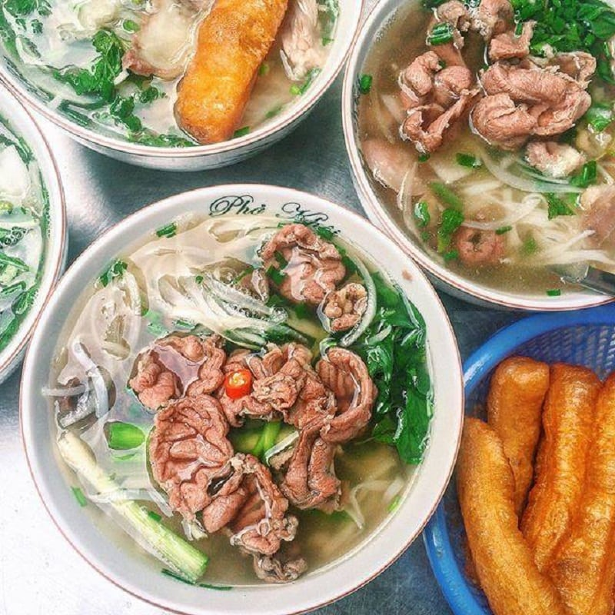
Welcome to a day of learning about local Vietnamese culture.

7:00 To start a new day, if you have not had breakfast, our guide will pick you up at the meeting point to go enjoy some Hanoi Pho.
Pho is a delicate dish that has become a characteristic of Hanoi people. No matter where far away, enjoying many other unique dishes, but the people of Hanoi always look forward to returning to enjoy this familiar dish as a warm taste of home.

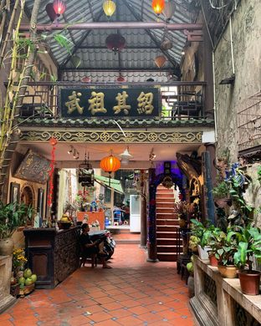
Then the guide will take you for a walk around the Old Quarter, the banks of Hoan Kiem Lake and talk about the cultural and historical beauty of Hanoi as well as the Vietnamese people.
Stop at the Garden Coffee with a unique Egg Coffee with an ancient atmosphere (Garden Coffee 11 Hang Gai). With the unique architecture of the 100-year-old old house, while sipping a cup of coffee mixed with the fat of Egg Cream, you can fully observe Hoan Kiem Lake from above - where you will surely visit if you have a chance to return to Hanoi.
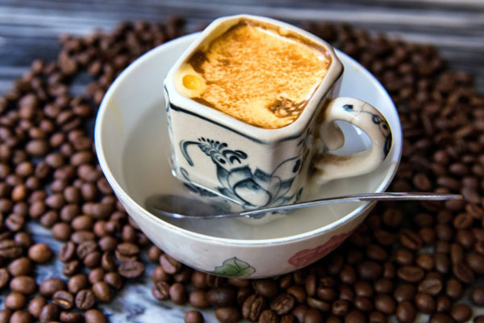

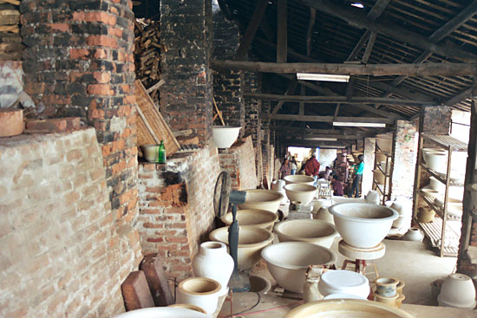
8:30 Pick up you to depart for Bat Trang Pottery Village. Travel time 30-45 minutes.

Bat Trang is a famous traditional craft village located near Hanoi with a history of more than 600 years of establishment and development. This place has become a historical witness, associated with many stories from ancient times. All create a very unique beauty as well as meaning in each product made by artisans in the village.
We will have the opportunity to visit the Ceramic Museum and experience cultural activities here such as:
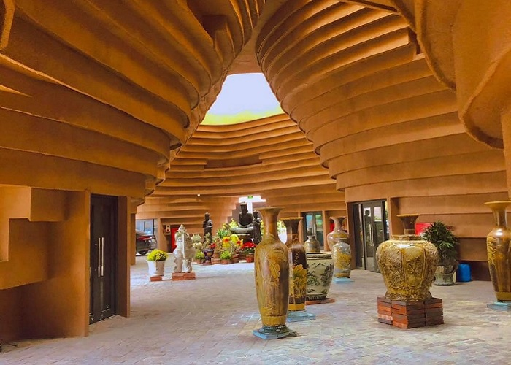

- The unique design of the Ceramic Museum is a giant spiral. It is explained that this is an image inspired by the turntables used to stroke and shape ceramic products. The soft, free and intertwined multi-faceted curved surfaces form a unique "masterpiece", which is both impressive and unique and perfectly expresses the soul of the design.

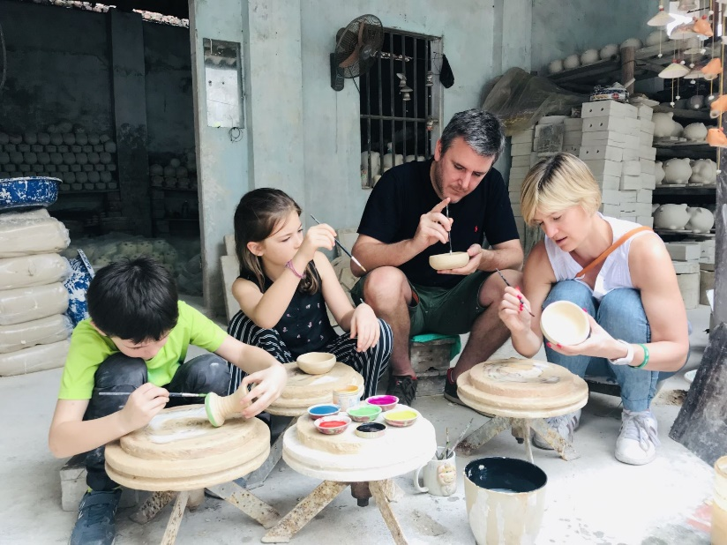
- Experience buying or participating in an auction at the Ceramic Museum: This is also an opportunity for you to better understand Bat Trang ceramic products, from the stages of making to decoration and the meaning of those motifs. So don't miss the opportunity and try it out! Usually these activities will be held on a fixed monthly schedule. If you want to participate, you should find out in advance so you don't miss it.

- Hand-made pottery experience: The staff here will teach you how to use the turntable as well as how to touch, stroke and shape to complete your own ceramic work. You can then take the product home as a souvenir.

After visiting the Ceramic Museum, the bus and guide will take you around the craft village area and go to the pottery market. Walking around the village, you will encounter ceramic walls, or unique doorways made from ceramic like colorful folk pottery paintings. Don't forget to take photos to keep the memories.

12h30: Have lunch at a restaurant, then return to Hanoi.
14h00: In the afternoon, you go to the silk display area and experience the workshop here.
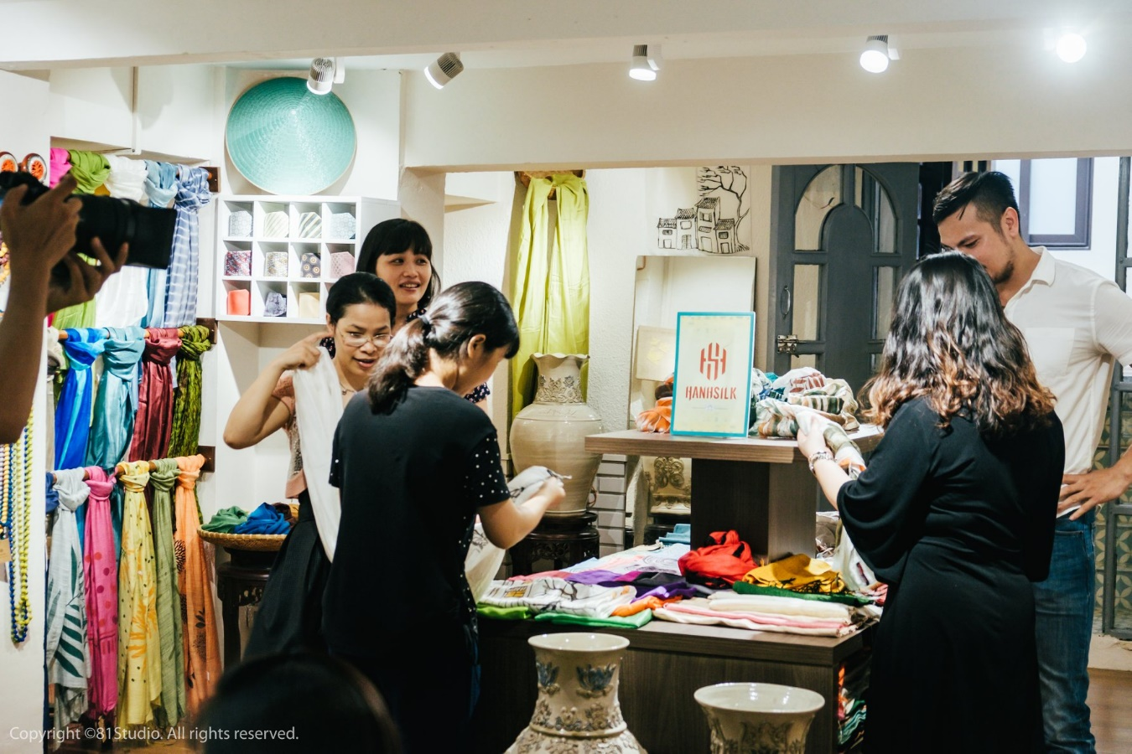

WORKSHOP’S DETAILS:
1. Learn the process of making silk
- Learn the process from growing mulberry to raising silkworms to weaving Nam Cao silk
- Distinguishing silk thread, skein yarn, real silk, fake silk in the market
- Listen to the story of Hanhsilk's ten-year journey to restore Nam Cao Silk.
2. Experience being an artist
- Listen to stories in English and act out the life cycle of silkworms
- Experience the steps of making silk with your hands
3. Experience threading & hand embroidery of silk scarves
- Experience as a silk scarf embroiderer
- Experience making silk bracelets
- Play the game, tear and glue to make a worm from materials

At the end of the workshop, you can shop at the booth displaying natural silk gifts that have met the testing standards.
Then the car and guide will drop you off at the meeting point in the city center or your hotel (with prior notice).
Hope you had a pleasant experience.

II/ INCLUDED:

- International, history-savvy guide accompanying you throughout the experience.
- New, clean and air-conditioned shuttle bus moving at points
- Drinking water 500ml/1 bottle/1 person
- 01 breakfast (Pho), 01 coffee or fruit juice, 01 lunch worth 200k/person.
- Tickets to visit Bat Trang Ceramics Museum (ceramic making experience, entrance ticket)
- Tickets to experience the Silk Workshop.

III/ EXCLUDED:

- 1-day travel insurance
- Expenses for meals outside the schedule
- Customer's personal shopping expenses
- Expenses for traveling outside the schedule.
- Tip for tour guide and driver (optional)

